- List of Reagents examined in this report:
Reagents | Lot Number
RNAse Free Water | 169038013
RNAse Free Water | 169016239
BM4 | 169038304
BM4 | 169021219
BM3 | 169037825
BM1 | 169016329
BM2 | 172011473
Pro K | 169045035
BR5 | 169037198
Paxgene RNA Spin Column | 169047761
Paxgene RNA Shredder | 169049789
Rotor Adaptors | CH-2143574
Ethanol 96% | 11911938
Ethanol 96% | 1923760

- The associated equipment:
QIAcube 1

- The acceptance Criteria for the results being run on that particular equipment
  - Mean A260 concentration (ng/ul) > 50 ng/ul
  - A260/A280 ratio between 1.9 – 2.1
- Results of the quarterly validation
 | A260 concentration (ng/ul) |  | A260/A280 absorbance ratios
Qiacube | Mean | Standard deviation | Mean | Standard deviation
1 | 56.62 | 6.86 | 2.09 | 0.01

- Do the quarterly validation results fall within acceptance criteria?
- Yes
  - The mean value of A260 concentration (ng/ul) is > 50 ng/ul and the validation is passed
  - The mean value of A260/A280 absorbance ratio within the acceptance range

- Can the reagents mentioned above be signed off as validated?
  - Yes
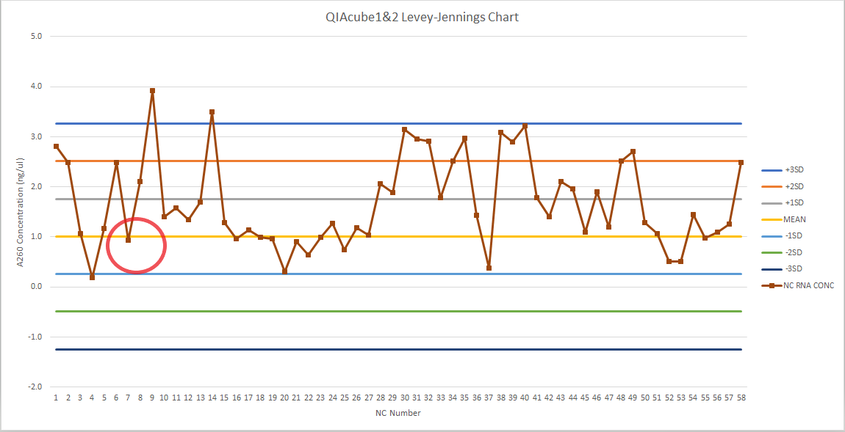
Negative control value is nearer to the mean for that batch tested.
Can the reagents mentioned above be signed off as validated?
Yes

